Communities Tour #1
Sunday, Aug. 30 / 10 Elul
Leaving Yerushalayim 9:30AM,
back at 9:30PM
Immanuel, Afula, and Karmiel
Touring the neighborhoods, meeting with locals including Americans / English speakers, getting an overview of the local kehillos, housing options and pricing, mosdos chinuch and the local kollelim etc.
170 NIS per person, 300 NIS per couple,
50 NIS if coming in your own car
(not for profit – to cover costs).

Registration - Yoel Berman – 053-3191618
yberman613@gmail.com

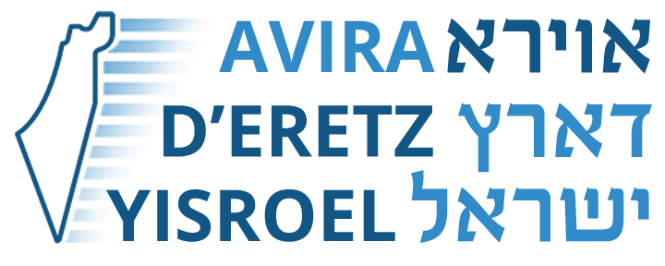
AviraDEretzYisroel.org

